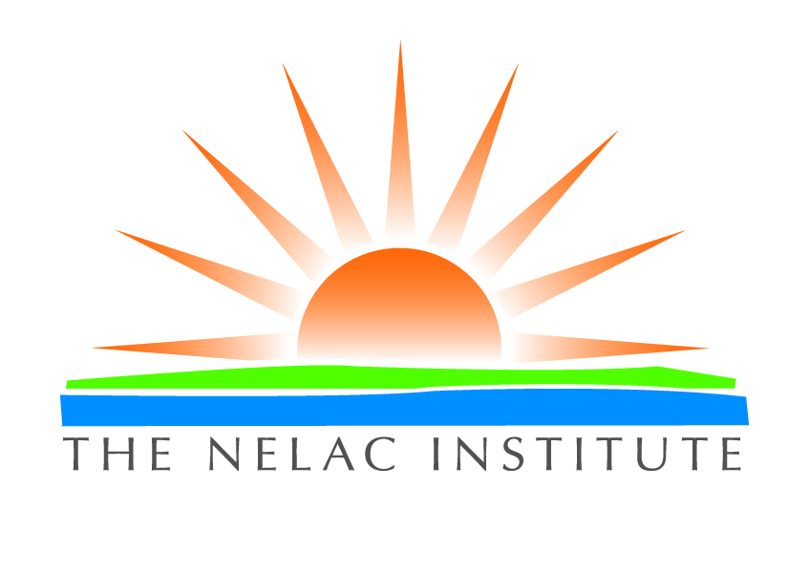

The NELAC Institute

Non-Governmental
Accreditation Body Application

P.O. Box 2439
Weatherford, Texas 76086

Instructions for Completing Application Form and Checklist (Addendum I):
1. The non-governmental accreditation body (NGAB) must supply copies of this Application and any supporting documents submitted with this Application to the NGAB Evaluation Coordinator.

2. When supporting documentation is submitted, such as copies of the applicable policy statements, quality manual, standard operating procedures, guidance documents, lists, etc., a clear citation of where specific required information is found in the documents must be provided on the Application Completeness Checklist. This citation must include a reference to the document title or identification, page number and/or section/chapter/line reference, as applicable.

3. The applicant accreditation body can submit this application and supporting documents required in this Application for NGAB recognition electronically or by certified or other traceable means. Electronic transfer of the application and supporting documents is preferred.

FOR TNI USE ONLY
Date Application Received:

1. Purpose of the Application:
Renewal Application for NGAB Recognition
Expansion of NGAB Recognition
New Application
2. Accreditation Body Name:

3. Accreditation Body Address:
Street:
P.O. Box:
City:
State: Zip:
4. Accreditation Body Telephone, Fax Number and Email Address:
Telephone:
Fax:
Email:
5. Environmental Laboratory Accreditation Program: Contact Person
Name:
Title:
Telephone:
Email:

6. AB Website with directory of accredited laboratories, if any. __________
Submit listing if website not available.

7. Hours of Operation (enter the hours in which the laboratory accreditation program operates):
Regular Office Hours:
8. Fees and Current Recognition
Please indicate type of application and $1000 fee enclosed.
____ New application
____ Renewal

9. Areas of Recognition:
Please attach Matrix/Technology Table
10. Additional Documentation:
Please submit quality manual and related SOPs or documentation to demonstrate implementation of the TNI standard. Please submit the completed checklist for the evaluation and the laboratory assessment checklist to be used by assessors for the assessment of CABs (laboratories)
Most recent Internal Audit Report
Most recent Management Review Report
Evaluation Checklist Completed
Personnel Listing, areas of responsibilities, and education for laboratory accreditation program
Assessor qualification descriptions for laboratory accreditation program (including contract assessors)
Example Contractual Agreements for subcontracting
List of contract assessors if not included in Quality Manual
Liability insurance and workman’s compensation insurance coverage
Documentation of other relevant recognitions
A copy of the policy governing accreditation body use of TNI NGAB symbol

11. Certification Statement:
This Application/Renewal form must be signed and dated by the individual with responsibility for accreditation activities for which NGAB recognition is being sought. By signature on this application, this individual attests to the validity of the information contained within this application and its supporting documents, and that the Accreditation Body meets the provisions of the applicable TNI standards, Volume 2: General Requirements for Accreditation Bodies Accrediting Environmental Laboratories
In accordance with the applicable TNI standards, Volume 2: General Requirements for Accreditation Bodies Accrediting Environmental Laboratories, I submit this completed application/renewal to TNI. I attest that all the information is true, accurate and complies with all applicable TNI standards, procedures and requirements.
Name (print or type):
Signature:
Date:

Send by email, certified mail or overnight delivery to the NGAB Evaluation Coordinator.

xxxxxx@yyyyyyyy.zzz

